Aim
To write a Java program that converts a given time from 12-hour AM/PM format into 24-hour (military) time format.
Algorithm
- Start
- Read the input time string s in the format HH:MM:SSAM or HH:MM:SSPM.
- Extract:
  - The hour part using substring(0, 2)
  - The middle part (minutes and seconds) using substring(2, 8)
  - The AM/PM part using substring(8)
- Convert the extracted hour part into an integer.
- If the time is AM:
  - If the hour is 12, change it to 00.
- If the time is PM:
  - If the hour is not 12, add 12 to the hour.
- Combine the updated hour part with the middle part.
- Display the converted time in 24-hour format.
- End

Program
import java.io.*;
import java.util.*;
class Result {
public static String timeConversion(String s) {
String hourPart = s.substring(0, 2);
String amPm = s.substring(8);
String middlePart = s.substring(2, 8);

int h = Integer.parseInt(hourPart);

if (amPm.equals("AM")) {
if (h == 12) hourPart = "00";
} else { // PM case
if (h != 12) {
h += 12;
hourPart = String.valueOf(h);
}
}
return hourPart + middlePart;
}
}
public class Solution {
public static void main(String[] args) throws IOException {
BufferedReader bufferedReader = new BufferedReader(new InputStreamReader(System.in));
BufferedWriter bufferedWriter = new BufferedWriter(new FileWriter(System.getenv("OUTPUT_PATH")));

String s = bufferedReader.readLine();
String result = Result.timeConversion(s);

bufferedWriter.write(result);
bufferedWriter.newLine();

bufferedReader.close();
bufferedWriter.close();
}
}

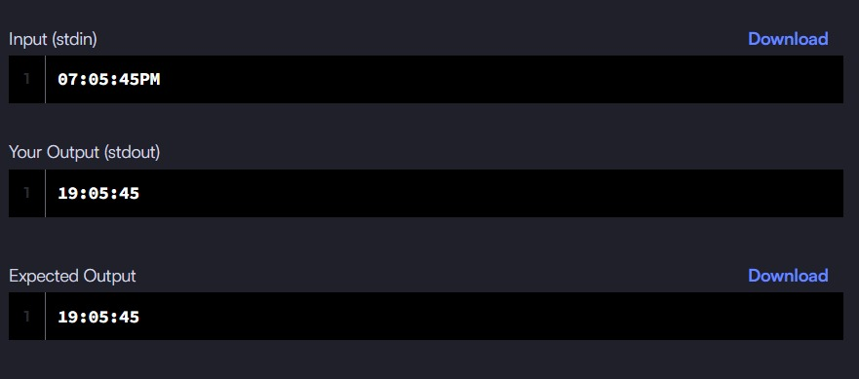

Aim
To write a Java program that moves all zero elements of an array to the end of the array while maintaining the relative order of non-zero elements.
Algorithm
- Start
- Initialize an integer variable lastNonZeroIndex to 0.
- Traverse the array from index 0 to n-1.
- For each element:
  - If the element is not equal to zero, place it at position lastNonZeroIndex and increment lastNonZeroIndex.
- After the first traversal, all non-zero elements are placed at the beginning of the array.
- Traverse the array from lastNonZeroIndex to n-1:
  - Assign 0 to each position.
- The array now has all zeros moved to the end.
- End

Program :
class Solution {
public void moveZeroes(int[] nums) {
int lastNonZeroIndex = 0;
for (int i = 0; i < nums.length; i++) {
if (nums[i] != 0) {
nums[lastNonZeroIndex++] = nums[i];
}
}
for (int i = lastNonZeroIndex; i < nums.length; i++) {
nums[i] = 0;
}
}
}

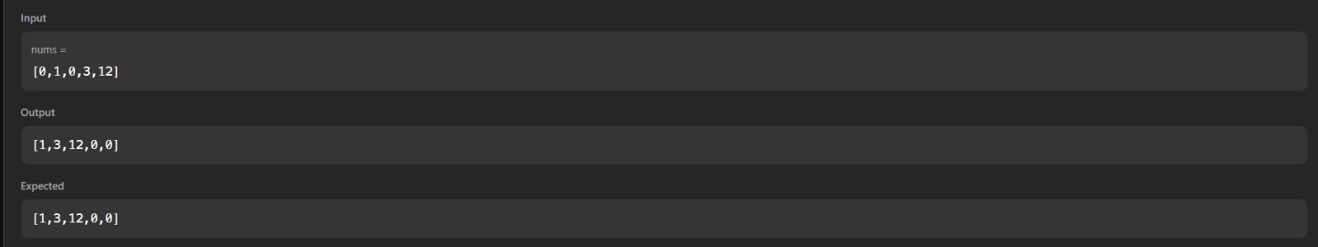

Aim
To write a Java program that calculates the absolute difference between the sums of the primary diagonal and secondary diagonal of a square matrix.
Algorithm
- Start
- Read the integer n, representing the size of the square matrix.
- Read the matrix elements into a 2-dimensional list arr.
- Initialize two variables:
  - primarySum = 0
  - secondarySum = 0
- Traverse the matrix using a loop from i = 0 to n - 1.
- Add the element at position arr[i][i] to primarySum (primary diagonal).
- Add the element at position arr[i][n - 1 - i] to secondarySum (secondary diagonal).
- Calculate the absolute difference using
|primarySum − secondarySum|.
- Display the result.
- End

Program :
import java.io.*;
import java.util.*;

class Result {

public static int diagonalDifference(List<List<Integer>> arr) {
int n = arr.size();
int primarySum = 0;
int secondarySum = 0;

for (int i = 0; i < n; i++) {
primarySum += arr.get(i).get(i);
secondarySum += arr.get(i).get(n - 1 - i);
}

return Math.abs(primarySum - secondarySum);
}
}

public class Solution {
public static void main(String[] args) throws Exception {
BufferedReader bufferedReader = new BufferedReader(new InputStreamReader(System.in));

int n = Integer.parseInt(bufferedReader.readLine().trim());

List<List<Integer>> arr = new ArrayList<>();

for (int i = 0; i < n; i++) {
String[] elements = bufferedReader.readLine().trim().split(" ");
List<Integer> row = new ArrayList<>();

for (int j = 0; j < n; j++) {
row.add(Integer.parseInt(elements[j]));
}
arr.add(row);
}

int result = Result.diagonalDifference(arr);
System.out.println(result);

bufferedReader.close();
}
}
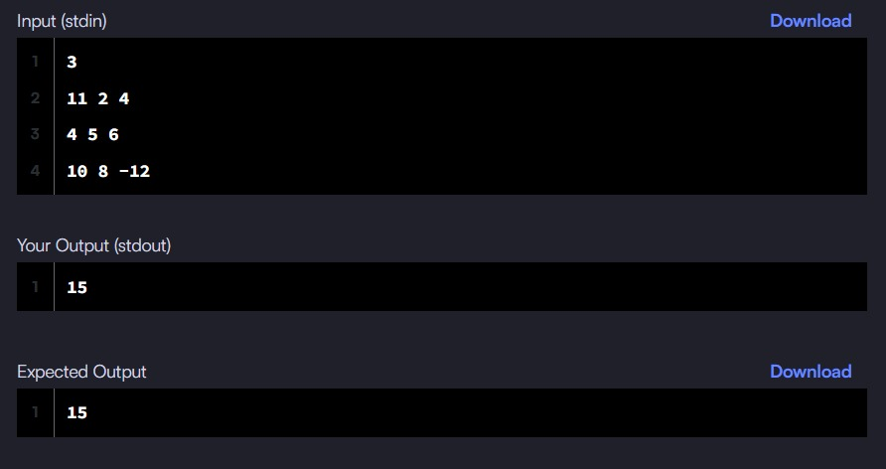
Aim
To write a Java program that finds the transpose of a given matrix by converting its rows into columns.
Algorithm
- Start
- Read the input matrix matrix.
- Determine:
  - Number of rows R
  - Number of columns C
- Create a new matrix result of size C × R.
- Traverse the original matrix using two loops:
  - Outer loop for rows (i = 0 to R - 1)
  - Inner loop for columns (j = 0 to C - 1)
- Assign each element of the original matrix to the transposed position:
  - result[j][i] = matrix[i][j]
- After completing the traversal, the result matrix becomes the transpose of the given matrix.
- Return the transposed matrix.
- End

Program :
class Solution {
public int[][] transpose(int[][] matrix) {
int R = matrix.length;
int C = matrix[0].length;

int[][] result = new int[C][R];

for (int i = 0; i < R; i++) {
for (int j = 0; j < C; j++) {
result[j][i] = matrix[i][j];
}
}

return result;
}
}

